# Collecting Photos in the Field

Photos can be used in mobile data collection projects to better describe a spatial object. Storing photos in the database is not trivial, and most of the time the path to the photo is stored. For this reason, an additional platform is needed to share photos where multiple users collect data.

## 3.1. Setting Up the Snycthing Environment

[Syncthing](https://syncthing.net/) is a continuous file synchronization program. It synchronizes files between two or more devices. The location of the shared folder is specified on Syncthing. It requires internet to synchronize the files. The aim of using Syncthing in this project is synchronizing photo folders between mobile device and computer.

Firstly, Syncthing must be installed on all devices. It can be downloaded for Windows from [here](https://github.com/canton7/SyncTrayzor/releases/tag/v1.1.24) as illustrated in Figure 20.There are options as x64 and x86. The suitable option can be downloaded. Note that SyncTrayzor is the name of the software on the desktop PC

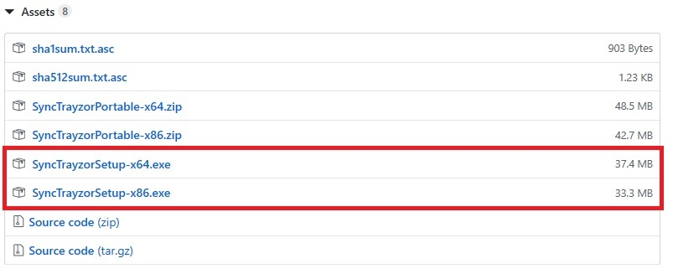

Figure 20 Installing Syncthing

Likewise, the app ‘Syncthing’ must be installed on the mobile device. It can be [downloaded](https://play.google.com/store/apps/details?id=com.nutomic.syncthingandroid) to android devices through Google Play. The logo of the app is illustrated in Figure 21.



Figure 21. Logo of the Syncthing app

Having installed Syncthing on both the PC and mobile devices, they are required to be connected. Open SyncTrayzor. Go to “Actions” 🡪 Show ID as shown in Figure 22.

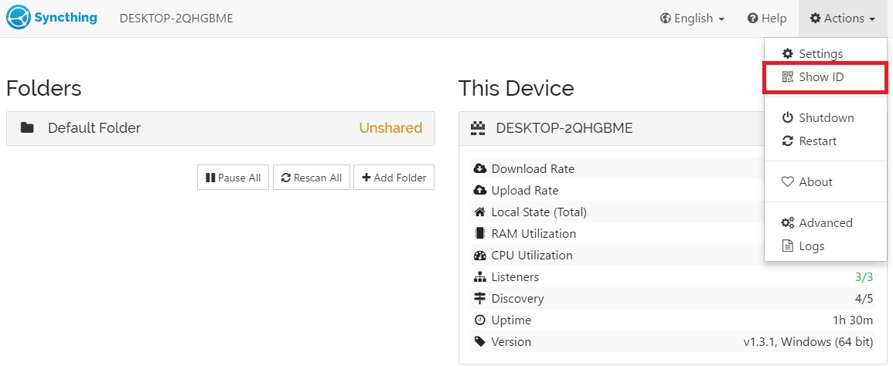

Figure 22. Getting the ID of the PC where each photo will be uploaded

The ID of a device is presented as a text and QR code as shown in Figure 23.

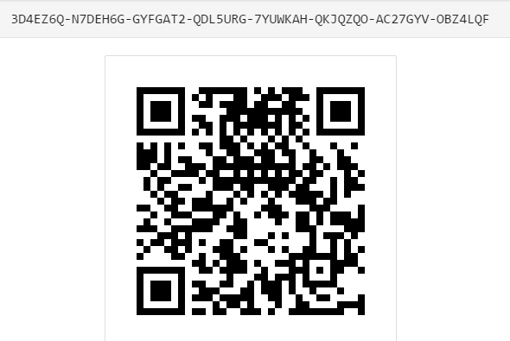

Figure 23. ID of a Snycthing device

This code must also be entered to the mobile device. Press the “+” button in the “Devices” menu as shown in Figure 24.



Figure 24. Synching the mobile device with PC

Device options will be shown. Enter the connection ID and connection name. Also, QR code can be used to set up the connection as illustrated in Figure 25.

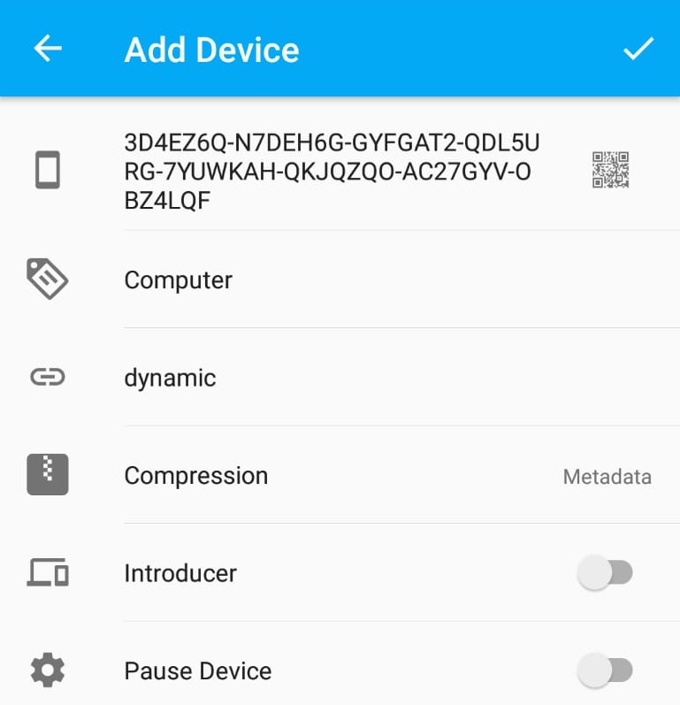

Figure 25 . Adding a device from mobile phone

Once the device is added, this action sends a request to the PC stating the details of the connection. Press the ‘Add Device’ as shown in Figure 26.

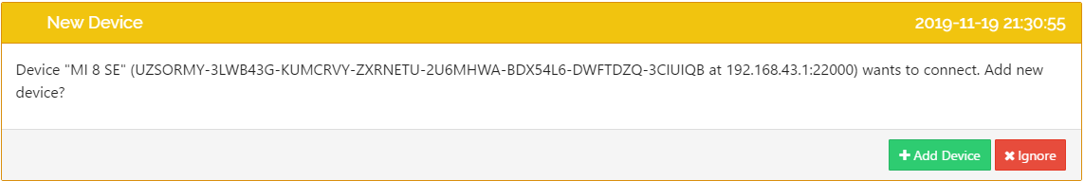

Figure 26. Accepting the request sent from the mobile device

After acceptance, connections will be shown in the SyncTrayzor as illustrated in Figure 27. The smart phone added in this tutorial is MI 8 SE.

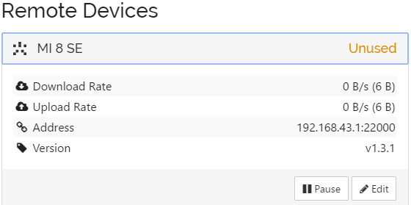

Figure 27. Connected devices – PC view

Also, Syncthing on the mobile device displays the connection information as illustrated in Figure 28.



Figure 28. Connected devices – mobile device view

After having reached this step, the mobile device and PC are connected. One may add further mobile devices. Once the connection is established between the devices, the details regarding file synchronization must be provided.

First of all, both Syncthing and Synctrayzor needs to know that photos are saved in a folder named ‘DCIM’ by default. Therefore, a folder named ‘DCIM’ opens in the project folder. It is important to remember transferring the ‘DCIM’ folder when transferring the project from the PC to the mobile device.

## 3.2. Updating the QGIS Project

The path of the captured photos must also be stored in the database. There are two different ways to add a ‘photo’ attribute to the ‘trees’ layer. First, the attribute can be added when creating the table in the database. The data type must be chosen as text. Second, it can be added from the QGIS project. This tutorial relies on the latter option.

Open the attributes table. Right click the ‘trees’ layer and press open attributes table. Firstly, press the ‘Toggle Editing Mode’ which is shown as 1 in Figure 29. Secondly, press the ‘New Field’ button which is shown as 2 in the same figure.

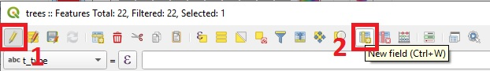

Figure 29. Adding a new attribute from QGIS

After that, enter the column name and select the type. Select type as ‘Text, unlimited length (text)’. Then, press OK as shown in Figure 30.

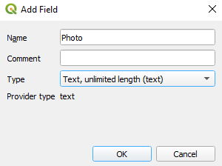

Figure 30. Adding a new field in QGIS

Close the ‘Toggle Editing Mode’ and press save.

The following adjustments have to be satisfied to display photos on QGIS:

1. Right click to ‘trees’ layer and press ‘properties’
2. Go to Attributes Form
3. Select the ‘Photo’ column
4. Select ‘Widget Type’ as ‘Attachment’
5. Enter default path of DCIM folder
6. Select ‘Relative paths’

These steps are shown in Figure 31.

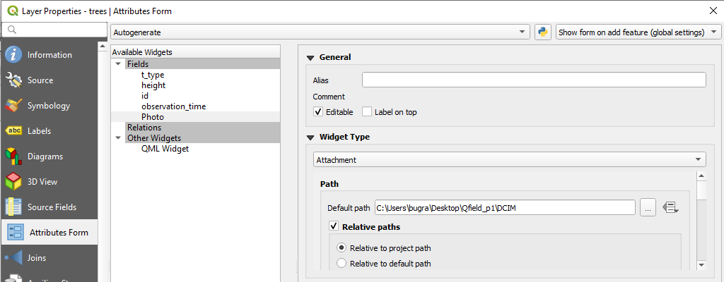

Figure 31. Configuring the photos field – part 1

Continue with the following steps:

1. Storage Mode select ‘file paths’
2. Display resources path option is selected
3. Also, ‘Display button to open file dialog’ option is selected as shown in Figure 32.

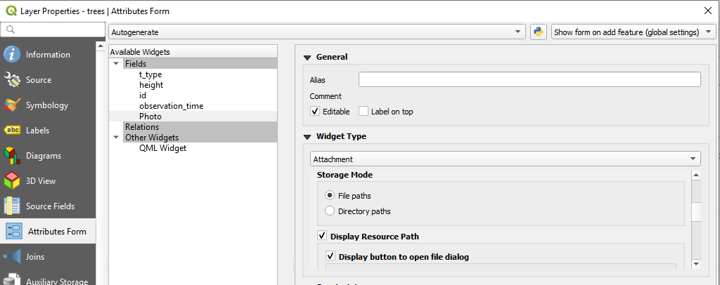

Figure 32. Configuring the photos field – part 2

The last thing to do is:

1. Selecting the ‘Integrated Document Viewer’ as image

After that press the apply button. The project is now ready to take photos.

Last step on photo synchronizing is that of sharing the photo folders. To synchronize the photo folder, press ‘Add Folder’ in the SyncTrayzor as shown in Figure 33.

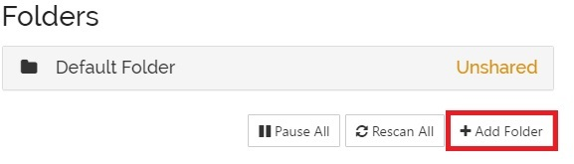

Figure 33. Adding the folder in SyncTrayzor for sharing photos with multiple users

Enter the folder name and folder path. It is important to enter the file location correctly as shown in Figure 34 to make sure that photos are displayed on QGIS.

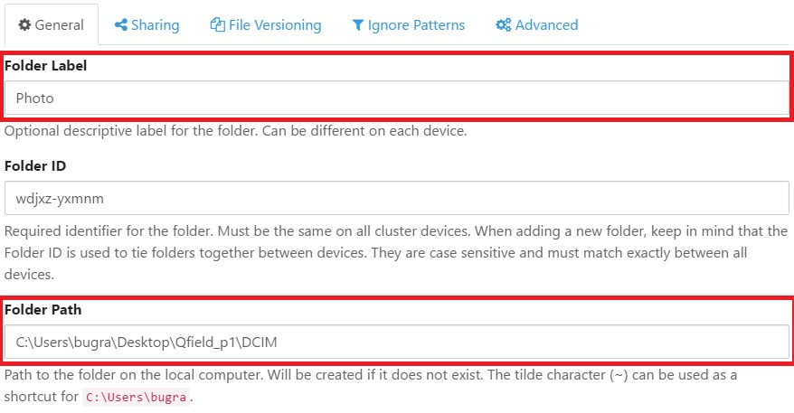

Figure 34. Setting the file synchronisation folder.

Select the mobile devices you want to synchronize the folder that contains photos in the ‘Sharing’ option and press ‘Save’ button as illustrated in Figure 35.

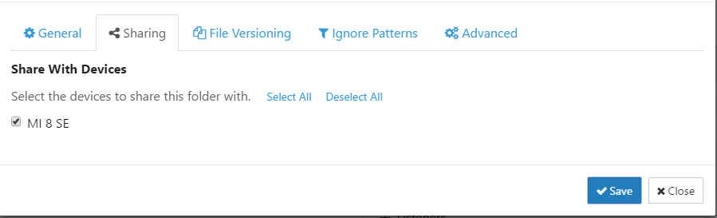

Figure 35. Selecting the devices to share the directory containing photos

This sends a request to the mobile device(s) selected to receive the corresponding acknowledgment from the mobile device user as illustrated in Figure 36.

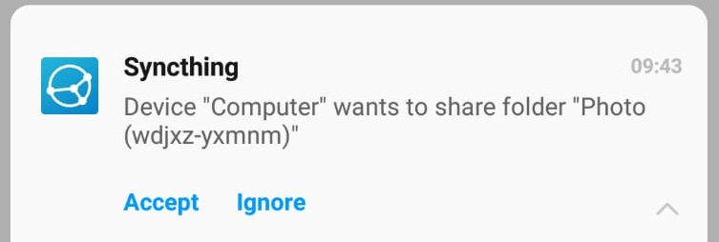

Figure 36.Share request sent to mobile device

Having accepted the request, the location of the 'DCIM' folder in the project must also be selected on the phone as illustrated in Figure 37.

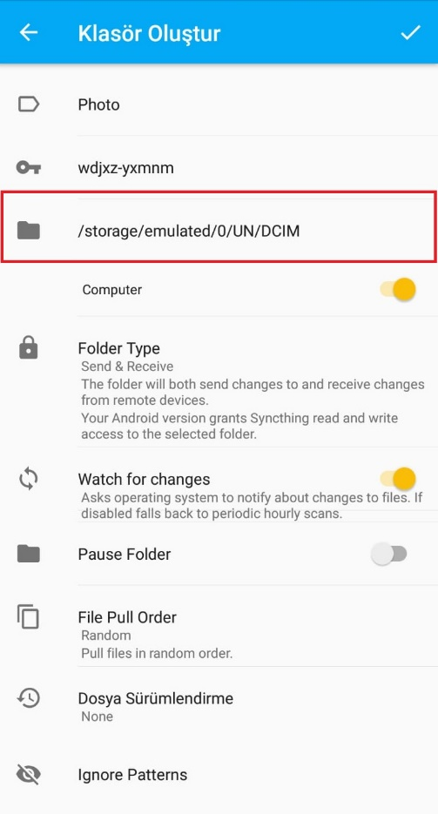

Figure 37. Setting up the mobile device to accommodate synched photos

Now the synched mobile devices are ready to take photos, which will be synched with the PC, as well as with other synched mobile devices.